Moscow Metro General Information.

As a rule Moscow Metro entrances are marked with large red letter "M" (illuminated in the evenings and late at night).

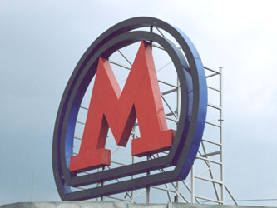

There are 12 lines in Moscow Metro. On schemes and pointers they are marked with different colors and numbers. For example, IKI is located near Kaluzhskaya station of the orange colored line (line number 6).

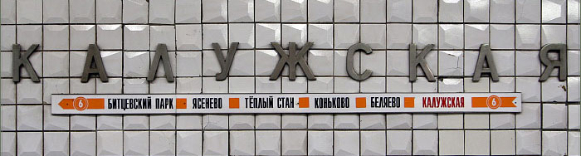

To help you find your way, there are several multicolored metro maps in every car, and a loud speaker that announces the name of the station at every stop. The doors open and close automatically.
To pay for your ride, buy a ticket (contactless smartcard) from the cashier in the metro entrance and apply it to the yellow ring of one of automatic fare gates on your right side. You may enter the station if red signal changes to green. You pay only for entrance, no matter how long you ride or how many transfers you make. One ride ticket costs 17 rubles, for 2 rides - 34 rubles, 5 rides - 75 rubles, 10 rides - 140 rubles.
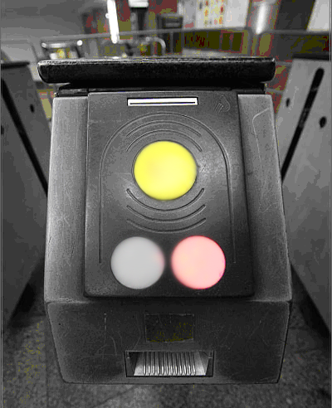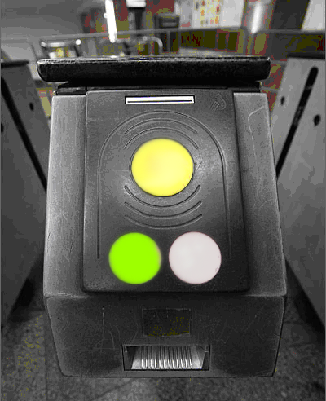

Do not enter Enter

Please remember that it is a legal requirement that you carry your passport at all times in the Russian Federation. A copy will not be sufficient.
Route descriptions

Metro station Kaluzhskaya – IKI

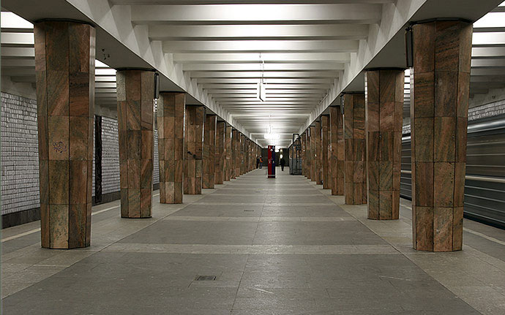
You should get off at "Kaluzhskaya" subway station using the southern exit. If you are going from the city center this exit will be in the direction of your travel (to the head of a train). After you got out the train doors, turn right and proceed to the escalator (moving staircases) in the direction of your train movement. Use the escalator to go upstairs. After leaving the station lobby through glass doors you should go STRAIGHT to the end of the tunnel (to the fast food kiosk), then take RIGHT and use the stairs to get to the surface. Here you should turn RIGHT and go about 150 meters along the highway (Obrucheva St) to the white and black iron fence with pink concrete base surrounding parking place. Here you turn LEFT and take a narrow path along this fence to the IKI building.
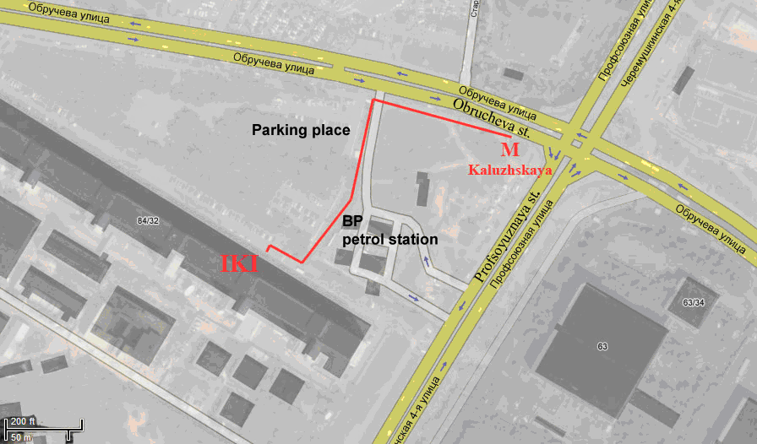
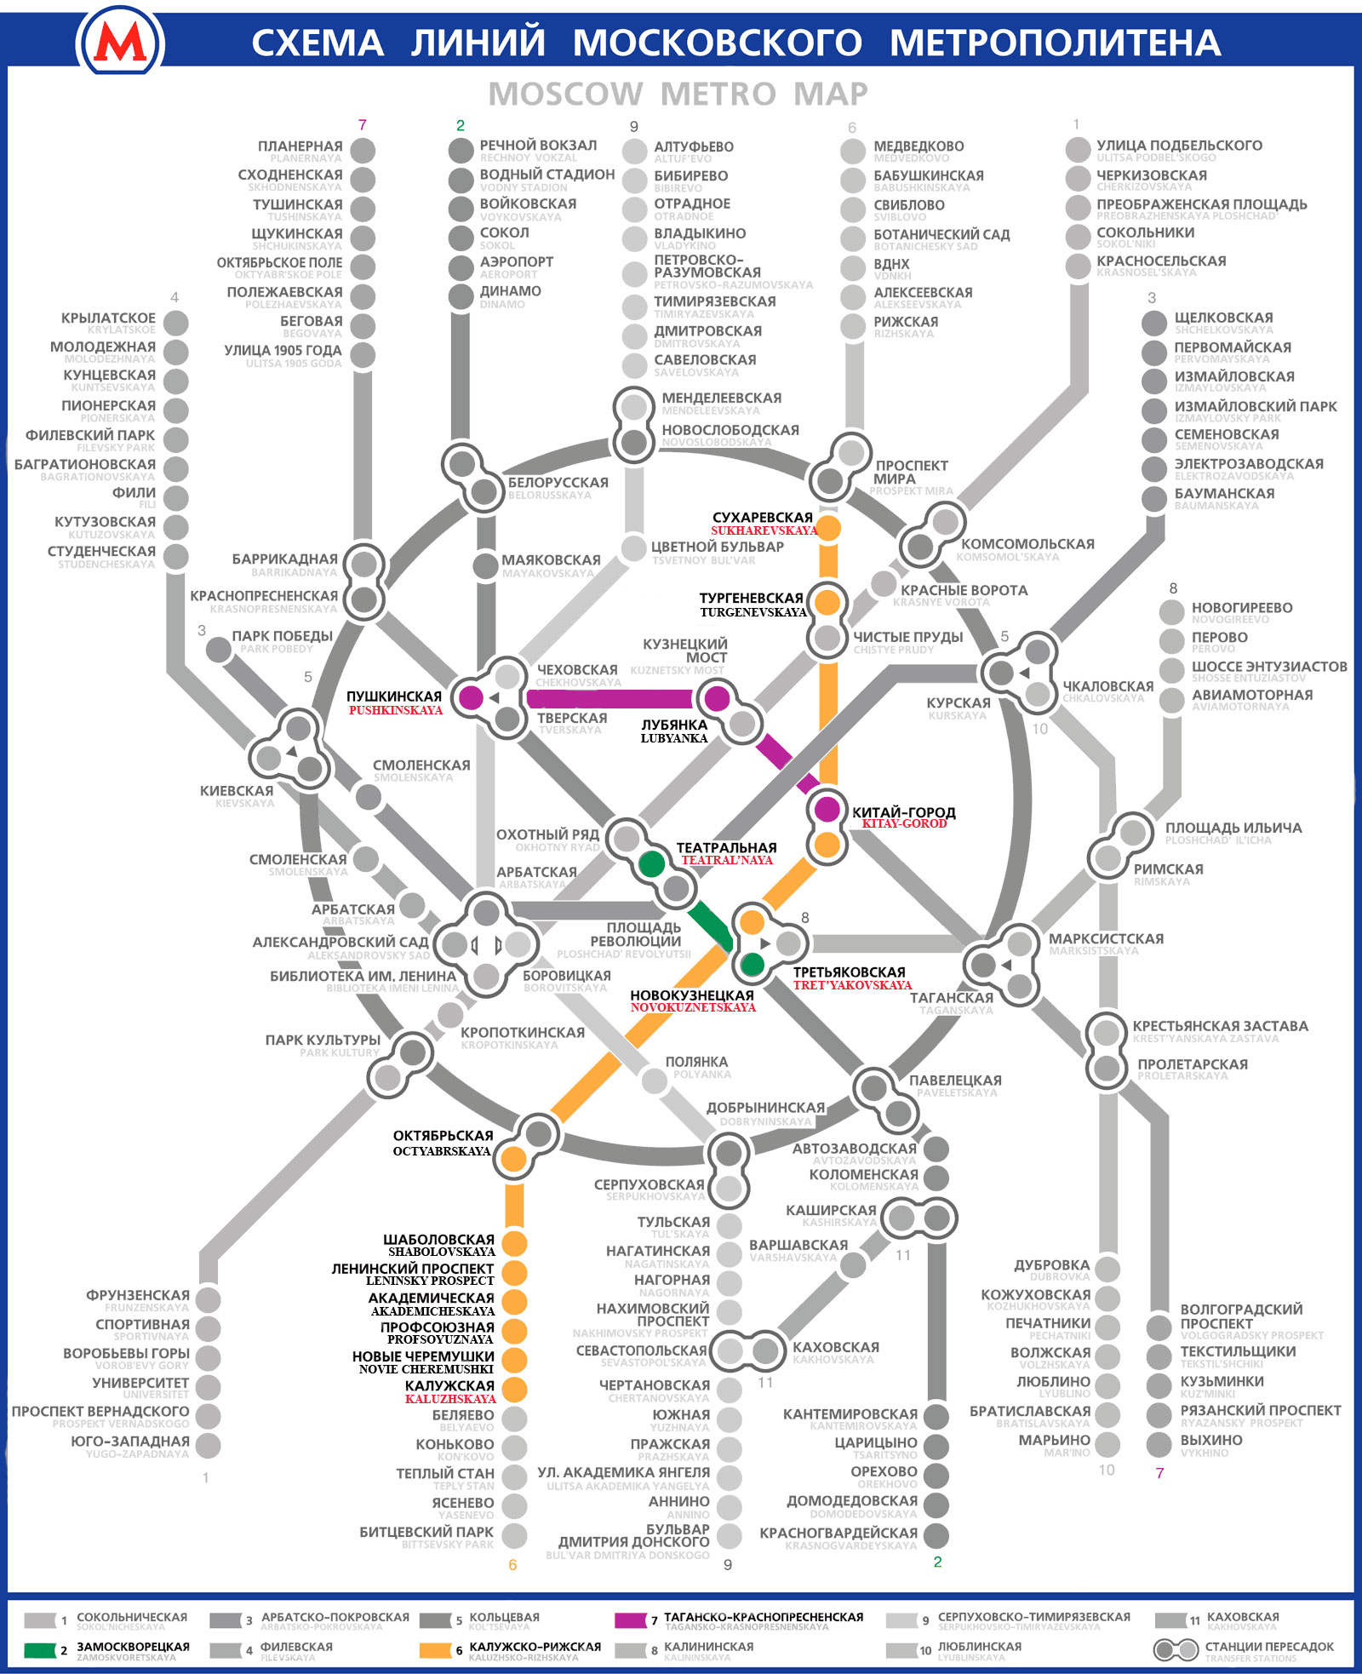

The simplified scheme of transfers along the routes from hotels to IKI
Metro Teatralnaya (Metropol hotel) – metro Kaluzhskaya

1. If you are standing at the main entrance of Metropol hotel, take a look to the left and you will see the red brick tower and next to it the yellow building with black pillars and big red letter M: this is the metro station Teatralnaya.
2. Enter the metro station. After automatic fare gates turn LEFT and go to the escalator (the sign shows “Teatralnaya” word (in Cyrillic) and is marked with green strip and number 2)
3. Use the escalator to go downstairs and turn LEFT to the train line.
4. Take the train and get out on the next stop “Novokuznetskaya”. Look for the sign at the center of the station hall which shows transfer to the “Tretyakovskaya” station (orange line, number 6). Go upstairs under this sign, then take the downstairs escalator and go LEFT to the train line.
5. Take the train (better get into the first or second car). “Kaluzhskaya” station will be the 7th stop.

Return trip metro Kaluzhskaya – metro Teatralnaya (Metropol hotel)

1. Enter the Kaluzhskaya metro station, go downstairs and take the train on the RIGHT side. “Tretyakovskaya” station will be the 7th stop.
2. At the center of the “Tretyakovskaya” station hall there will be the transfer to the “Novokuznetskaya” station. Look for the sign with green strip and number 2. Go upstairs, then LEFT by the long passageway, and take escalator upstairs. Take the RIGHT train line.
3. Get into the train and get out on the next stop “Teatralnaya”. Go LEFT and take upstairs escalator to exit the station.
4. Turn LEFT on the street. The Metropol hotel will be just in front of you.

Metro Kitay-gorod (Metropol hotel) – metro Kaluzhskaya

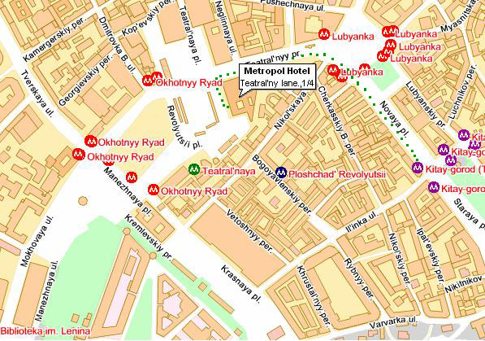

1. After leaving the hotel, turn RIGHT, turn around the hotel corner and walk to the RIGHT along the “Teatralny proezd” street for a couple of minutes till you reach the green building where you should turn RIGHT. Go past the entry to the “Lubyanka” metro station and walk for five more minutes along the “Novaya Ploshchad” street. About the building with street number 16 you will see big red letter M, marking Kitay-gorod metro station.
2. Go downstairs, next through the long passageway, the entry to the station will be to the RIGHT.
3. After you pass the automatic fare gates take the escalator downstairs, go RIGHT and downstairs, then LEFT to the train line. “Kaluzhskaya” station will be the 8th stop.

Return trip metro Kaluzhskaya – metro Kitay-gorod (Metropol hotel)

1. Enter the Kaluzhskaya metro station, go downstairs and take the train on the RIGHT side. “Kitay-gorod” station (orange line, number 6) will be the 8th stop.

2. Turn RIGHT to the stairs; go upstairs, then STRAIGHT along the passageway to the escalator upstairs. After leaving the station lobby through glass doors turn LEFT to the tunnel and then turn RIGHT and go upstairs to the street.

Metro Sukharevskaya (Volga-Moscow hotel) – metro Kaluzhskaya

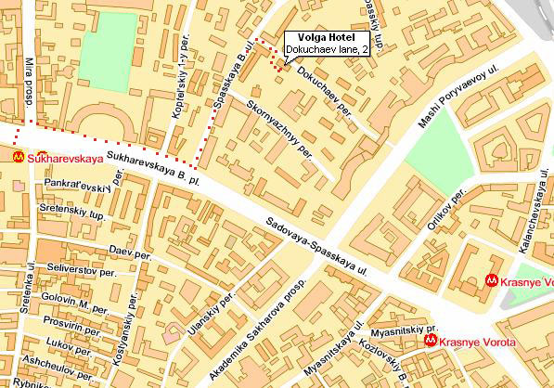

1. Metro station Sukharevskaya (orange line, number 6) entrance is located near small church with green cupolas. Go downstairs, turn RIGHT and enter the metro station. After you pass the automatic fare gates take the escalator downstairs, turn LEFT to the train line. Take the train (better get into the first car).

2. “Kaluzhskaya” station will be the 10th h stop.

Return trip metro Kaluzhskaya - metro Sukharevskaya (Volga-Moscow hotel)

1. Enter the Kaluzhskaya metro station, go downstairs and take the train on the RIGHT side. Take the train (better get into the last car).

2. “Sukharevskaya” station will be the 10th stop. Take off the train and turn RIGHT, use the escalator to go up. There is only one exit.

Metro Pushkinskaya (Golden Apple hotel) – metro Kaluzhskaya

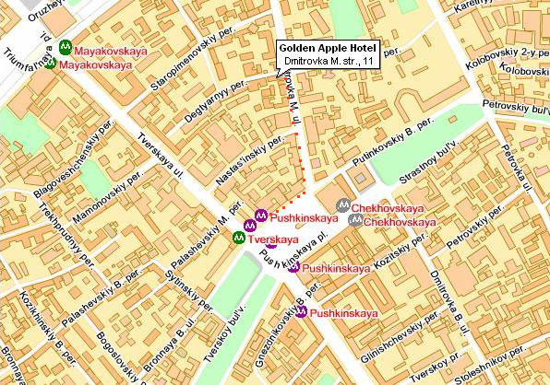

1. After leaving the hotel, turn RIGHT and walk along “M. Dmitrovka” street for about 300 meters, turn RIGHT and continue walking along “Pushkinskaya square” street about 150 meters. Then turn round the corner and there you will see the entrance to Pushkinskaya metro station.
2. Enter the station. Turn RIGHT, use the escalator downstairs and then STRAIGHT to the “Pushkinskaya” station (magenta line, number 7). After you pass the automatic fare gates take the escalator downstairs, turn RIGHT to the train line. Take the train and get out on 2nd stop “Kitay-gorod”.
3. Simply cross the platform to change your line (to orange line, number 6). Take the train and get out on the 8th stop “Kaluzhskaya”.

Return trip metro Kaluzhskaya - metro Pushkinskaya (Golden Apple hotel)

1. Enter the Kaluzhskaya metro station, go downstairs and take the train on the RIGHT side. Take the train (better get into the last car). Get out on 8th stop “Kitay-gorod” (orange line, number 6).
2. Simply cross the platform to change your line (to magenta line, number 7). Take the train and get out on 2nd stop “Pushkinskaya”.
3. Turn RIGHT to the escalator at the end of the hall. Use the escalator to go up and go STRAIGHT to another escalator upstairs. After leaving the station lobby through glass doors you should go LEFT and turn round the corner. Walk along “Pushkinskaya square” street for about 150 meters, turn LEFT and walk along “M. Dmitrovka” street for about 300 meters to your hotel.

