STAR PATTERN IDENTIFICATION : APPLICATION TO THE PRECISE ATTITUDE

DETERMINATION OF THE AURORAL SPACECRAFT

J.Cl . Kosik

Division Mathematiques Spatiales, CNES, Toulouse

Introduction :
The Auroral Spacecraft is one of the four satellites launched for the Interball project by the Russian Space Agency in cooperation with the international scientific community which are dedicated to magnetospheric research. This spacecraft is subject to the effects of energy exchange between the flexible booms and the main body. This energy pumping over induced a rise of the nutation angle and the exponential rise was damped by gas jets each 12 hours. As a consequence the spin rate was periodically slightly modified and the images of the on-board cameras were blurred. Orbit determination accuracy was also limited by the availability of only one tracking station, the orbit error inducing a shift in the reference magnetic field. The measured magnetic field was also perturbed by Field Aligned Currents, thus the attitude determination went inaccurate in the region of scientific interest. All these problems which were left aside in a first intensive attitude production were recently reassessed and the present status of their solution is described in this work. Of particular interest was the possibility to use star information given by the canadian auroral cameras. Auroral cameras cover a large field of view (more than 400 square degrees) and stars are observed outside the limb of the Earth. This star information can be used as soon as the stars seen by the auroral cameras can be identified. Several identification algorithms were previously developed for the Gamma project. These algorithms have been adapted to the Sun workstation. In the first part of this paper we briefly review the strengths and weaknesses of these algorithms. For the Auroral cameras we have selected the Distance-Orientation algorithm. This algorithm requires an approximate attitude determination. Our immediate goal was the obtention of this approximate attitude and the tools developed are described in the second part of this work. A quaternion approach using the Triad method was interested but failed in the FAC’s regions. In another attempt the attitude was calculated at the first point using the Triad method and then numerically propagated using the Euler-Poinsot equations and gradient gravity torques. This method gave a good average attitude with the prerequisite of the right spin rate. It also had the advantage to « ignore » FAC’s regions. Star identification was possible after an adequate choice of the parameters. A series of results for Orbit 689 and the two cameras are presented. These results are discussed in the last part of the work and future steps of this work are sketched.

THE IDENTIFICATION OF STARS:
Identification of star patterns was first used in CNES for the Gamma Project. Three algorithms have been developped and tested on star pattern images obtained in Pamir with a star sensor from Poland. One of these algorithms, the polygonal algorithm, has been described by Gottlieb in (Ref.1) . Two new algorithms, the Pivot algorithm and the Distance-Orientation algorithm have been developed. We will briefly review these three algorithms.

The Polygon Match :

This algorithm is described by Gottlieb (Ref.1). From a set of measured stars, we arbitrarily select two stars, 1 and 2, and compute the corresponding angular separation $d_{m}^{\text{12}}$. We then look for all pair of stars (i,j) in a finite region of the catalog around the approximate boresight of the star sensor, such that :

$\left|d\left(i,j\right)−d_{m}^{\text{12}}\right| ≤ ε$

where $ε$ is the uncertainty in the distance measurements of the star sensors and $d\left(i,j\right)$is the angular separation calculated for the pair of stars in the catalogue.

2m
*

* 3m
First step : We look for stars i,j
Such that

[d(i,j) – d12 ] < ε

We usually obtain many pairs

* 4m

*
* 5m

1m

FIG.1

Usually the number of star pairs is not negligible. Even if we obtain one pair of stars, there are two possible identifications. In both cases it is necessary to select another measured star, 3, from which we compute two more separations, $d_{m}^{\text{13}}$ and $d_{m}^{\text{23}}$. We now look for a third star, k, in the catalogue that can be combined with the previous pairs such that :

$$\left|d\left(i,j\right)−d_{m}^{\text{13}}\right| ≤ ε \text{and} \left|\left(d(j,k\right)−d_{m}^{\text{23}}\right|≤ ε$$
or
$\left|d\left(j,k\right)−d_{m}^{\text{13}}\right| ≤ ε \text{and} \left|d\left(i,k\right)−d_{m}^{\text{23}}\right| ≤ ε$

* 2m

* 3m

* 1m

FIG.2

If more than one pair is found the process must be repeated until the identification is unambiguous.

Pole Technique :

If the number of stars is important enough, more than 7 stars, it is possible to use the pivot algorithm . We choose a given measured star (labeleled 1 in Fig.3) and call it the pole star. To this pole star we associate all the measured distances to the other remaining distances, 8 distances for a total number of 9 measured stars. For each measured separation we look for the pairs (i,j) in the catalog which satisfy the distance criterion as defined in the previous paragraph. We obtain a set $Ε_{1m}$ where m identifies the measured star different from the pivot star. The pole star must be found in each of these sets $Ε_{1m}$. The pole star is thus the intersection of all the subsets $\underset{m}{intersect}Ε_{1m}$ (Fig .3) .

*
3m

2m
*
*
4m
E1
E2
d13

d14

d12
E3
*
5m
d15
E4

*
1m

FIG.3

Distance-Orientation algorithm :

It is possible to improve the polygon technique if we have a crude estimate of attitude. The crude estimate of the attitude enables the projection of the star catalogue region onto the star sensor field of view. The same stars should be found, projected onto a tilted « theoretical » star sensor . As a consequence the adequate pairs should verify the distance criterion as above, but should also have approximately the same orientation : each pair can be considered as a vector and the vectors both of measured stars and projected catalogue stars should have approximately the same orientation (Fig.4). The distance-orientation criterion can be expressed as :

$$\left\|{\vec{V}}_{c}^{\text{12}}\right\| −\left\|{\vec{V}}_{m}^{\text{12}}\right\| ≤ ε \text{and} \frac{{\vec{V}}_{c}^{\text{12}} ⋅ {\vec{V}}_{m}^{\text{12}}}{\left\|{\vec{V}}_{c}^{\text{12}}\right\| \left\|{\vec{V}}_{m}^{\text{12}}\right\|} ≥ 1−Δ$$

Where the last inequality expresses that the angle between the two vectors should be small enough .

Vc
Is equivalent to

*

*

and

Vm

FIGURE 4

In this algorithm a set of catalogue pairs is obtained from the distance criterion. The application of the orientation criterion leads to a subset. Each pair which can satisfy the orientation criterion for angles around 0° and also for angles around 180°. The obtention of an angle around 180° simply means that the order of the catalogue stars is opposite to the right order, i .e., if a catalogue pair (1c,2c) compared to measured pair (1m,2m) differs from about 180° , then the catalogue star 1c corresponds to star 2m and the catalogue star 2c corresponds to star 1m : the orientation-distance algorithm is already more powerful than the distance criterion algoritm as the aforementionned ambiguity is suppressed. If more than one pair of stars is obtained it is necessary to select another measured star and continue the process.

Algorithm efficiency :

The distance-orientation algorithm which requires a crude attitude attitude is the most powerful algorithm. Results can be obtained with 2 or 3 measured stars. The polygon match algorithm requires 4 to 5 stars. The least efficient algorithm is the pivot algorithm which requires more then 7 stars. In any case the corresponding software for these algorithms is quite complex and increases with the number of measured stars and the number of stars of the catalogue in the boresight region. As a consequence the identification of stars is the most difficult in the Milky Way region. Some statistical studies have been performed by Kosik (Ref.2)

PRECISE ATTITUDE DETERMINATION OF STARS USING THE AURORAL CAMERAS:
A precise attitude determination of the Interball Auroral spacecraft can be obtained using the star patterns observed by the auroral cameras. The identification of stars is obtained with the distance-orientation algorithm which requires the knowledge of the crude attitude of the spacecraft. In order to avoid the problems linked to Field Aligned Currents an Euler Poinsot scheme has been developed.

Calculation of the approximate attitude :
The attitude of the spacecraft at the initial point can be obtained using the sun and magnetic field information at this point and the TRIAD method described by Lerner (Ref.3). This initial attitude is propagated using the Euler-Poinsot equations and the gravity-gradient torques. The Euler-Poinsot equations are solved by numerical integration and the gravity gradient torques are calculated using the position of the spacecraft given by the orbit file. The integration process is stopped for the time of the aurora and star snapshot. Figure 5,6,7 show the reference magnetic field components together with the measured magnetic field components in the Solar Magnetospheric frame of reference. An oscillation of the measured magnetic field components can be observed.

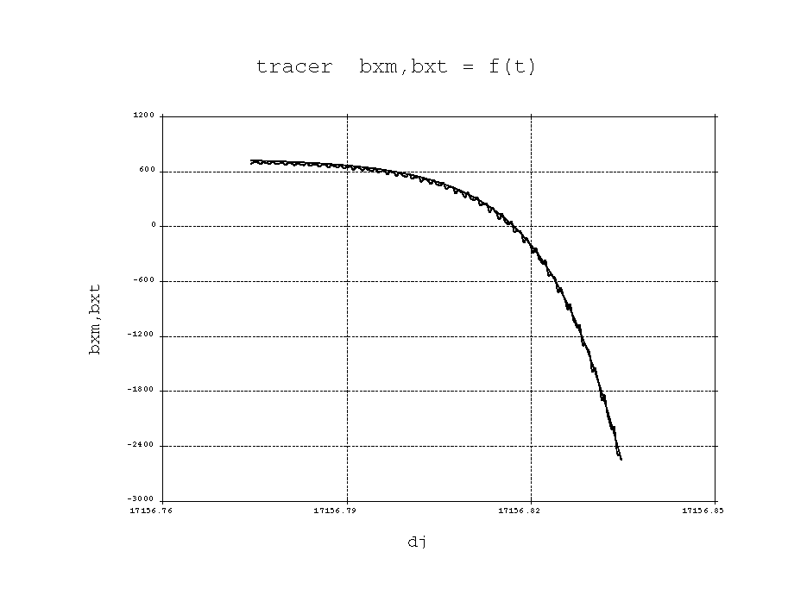

FIGURE 5

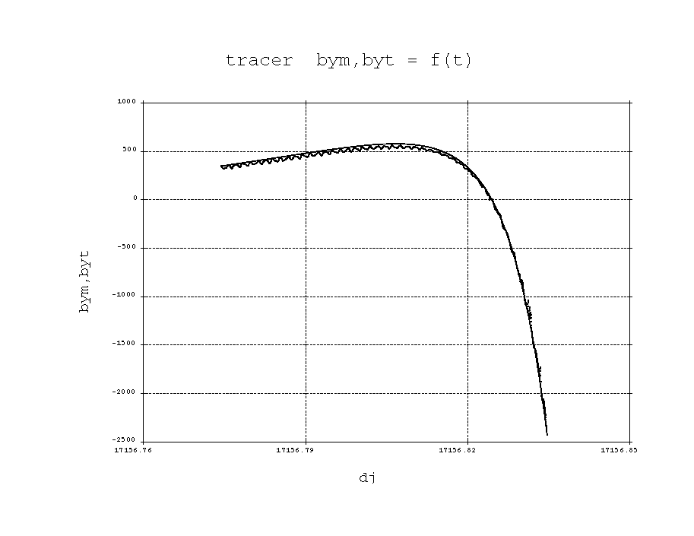
FIG.6

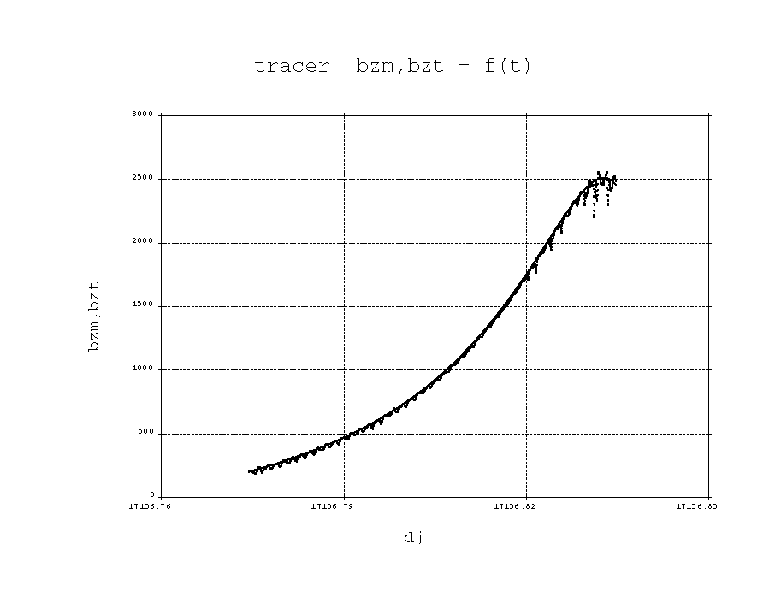

Fig .7

Problems encountered in the calculation of the approximate attitude :
In the standard case the tracing of the magnetic field measured and calculated gives an oscillating curve for the measured magnetic field and a non-oscillating curve for the theoretical magnetic field as in figures 5, 6, 7. However, the theoretical magnetic field curve can deviate from the measured magnetic field as in figure 8,9,10.

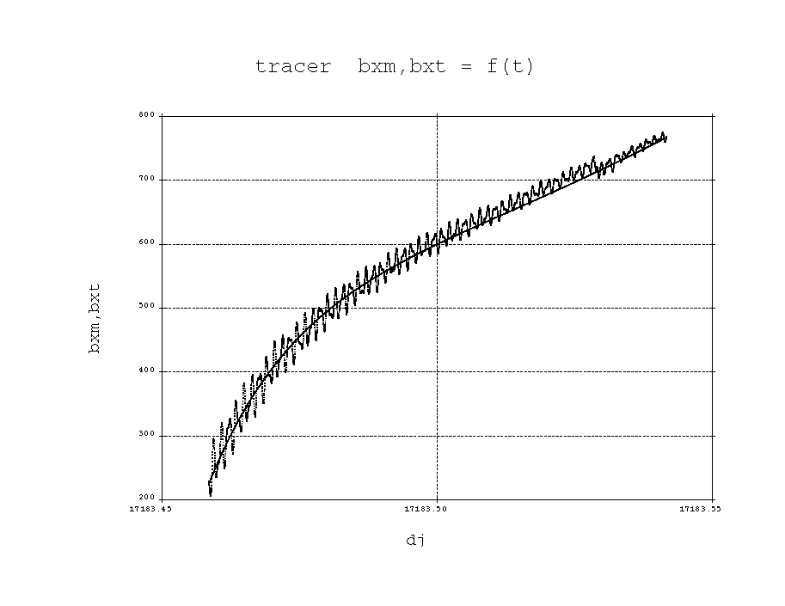
Fig .8
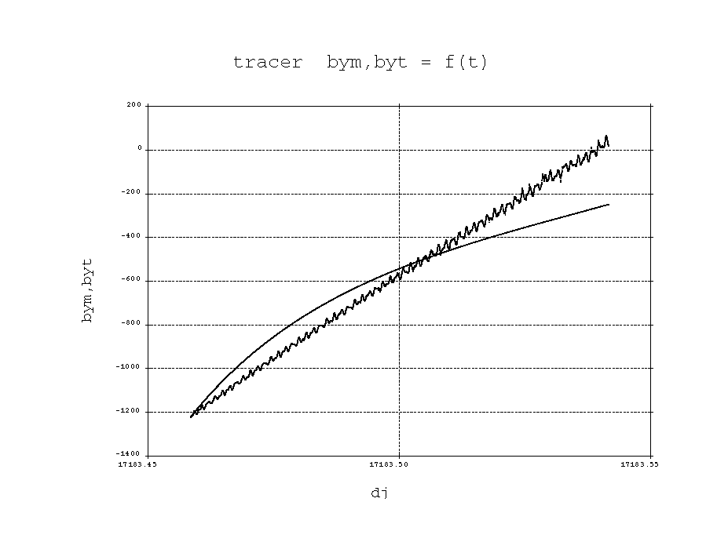
Fig.9

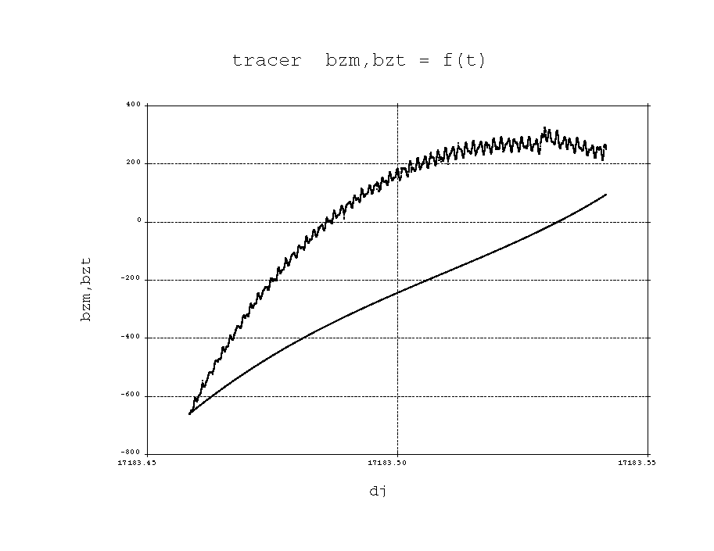
Fig.10

This phenomenon is due to the non adequate spin rate in the Euler-Poinsot integration. The adequate spin rate can be found through the minimization of the difference between the modulus of the reference magnetic field and the modulus of the measured magnetic field, difference calculated along the orbit arc. Figures 8, 9, 10 correspond to a spin rate of 0.05236 radians/s and figures 11, 12 and 13 correspond to a spin rate of 0.05246 radians/s.

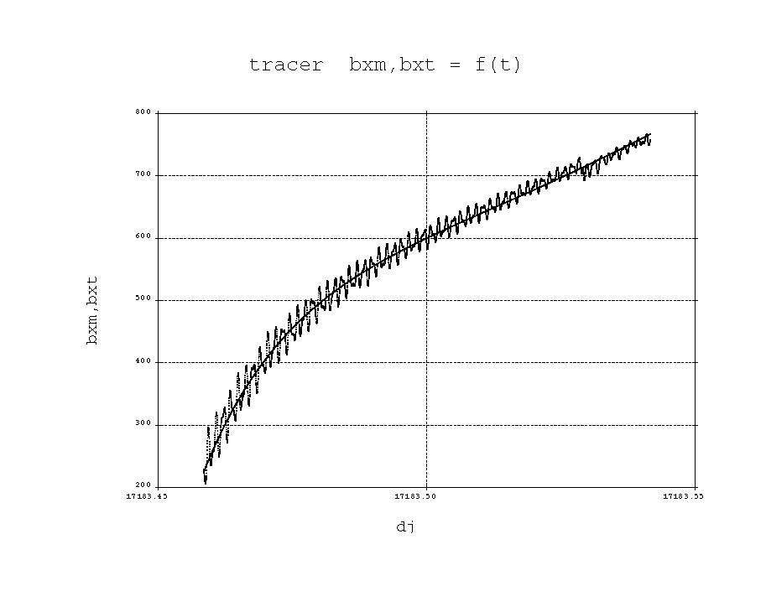
Fig.11
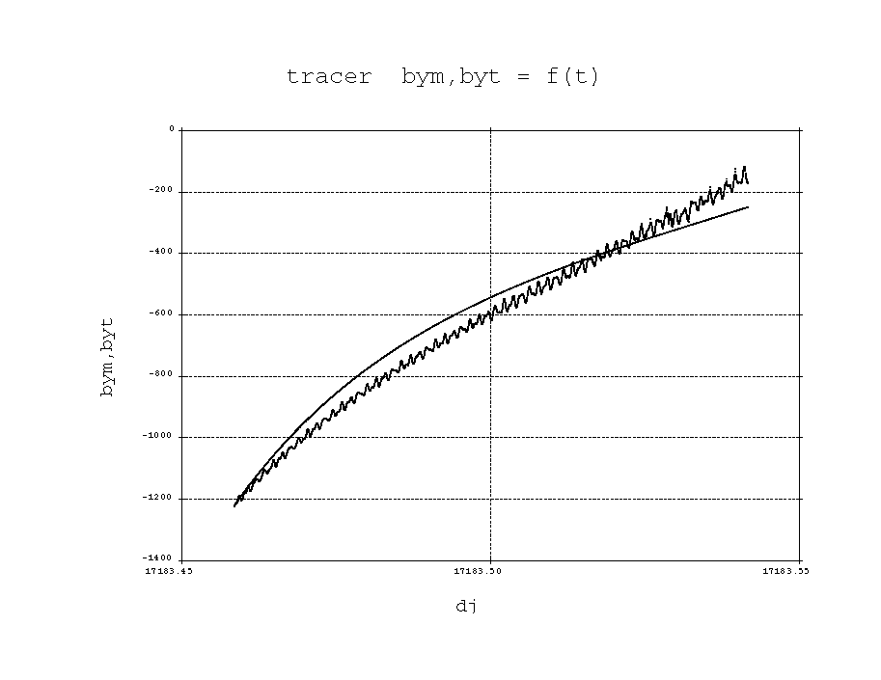
Fig.12
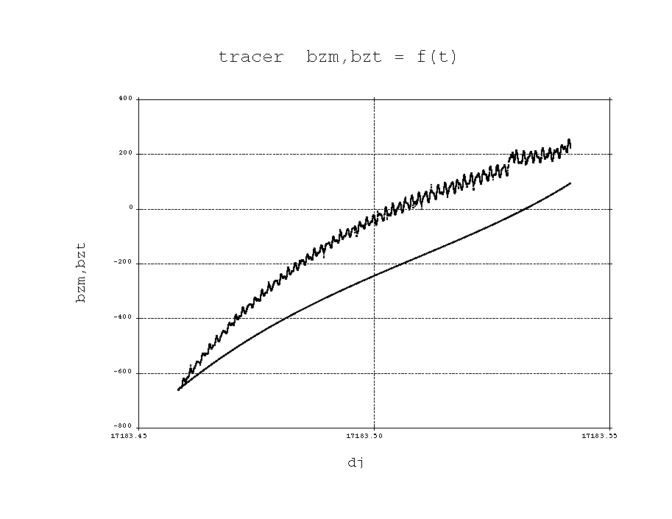
Fig.13

The adequate spin was found to be 0.05256 rad/s as shown in figures 14,15 and 16

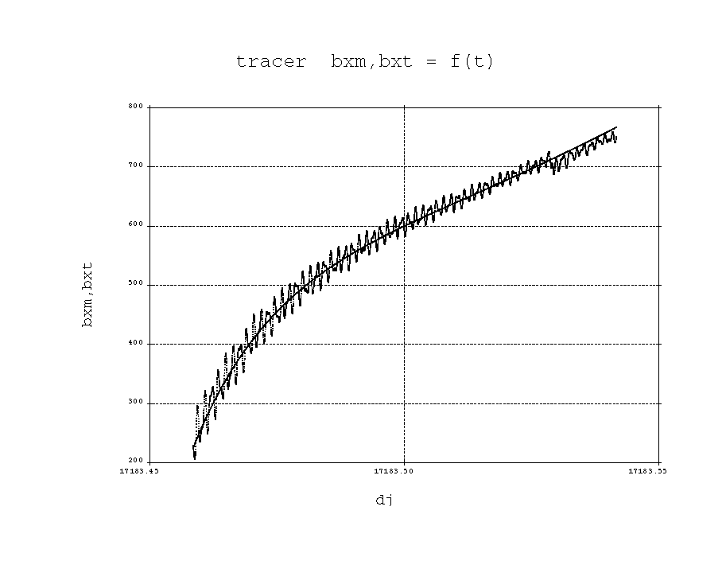

Fig .14

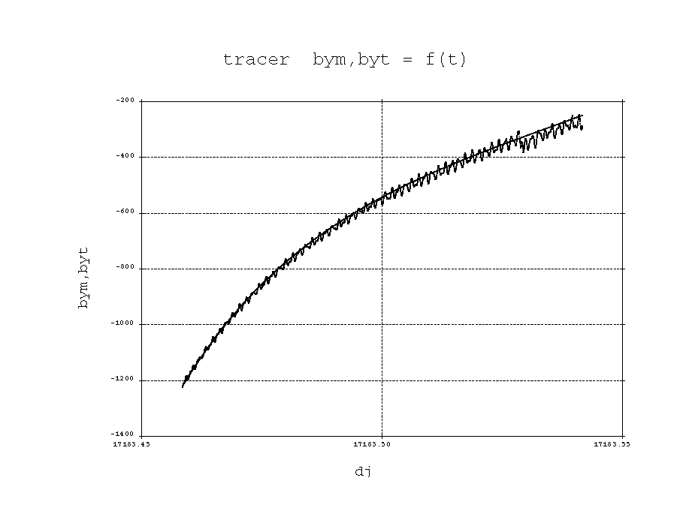

Figure 15

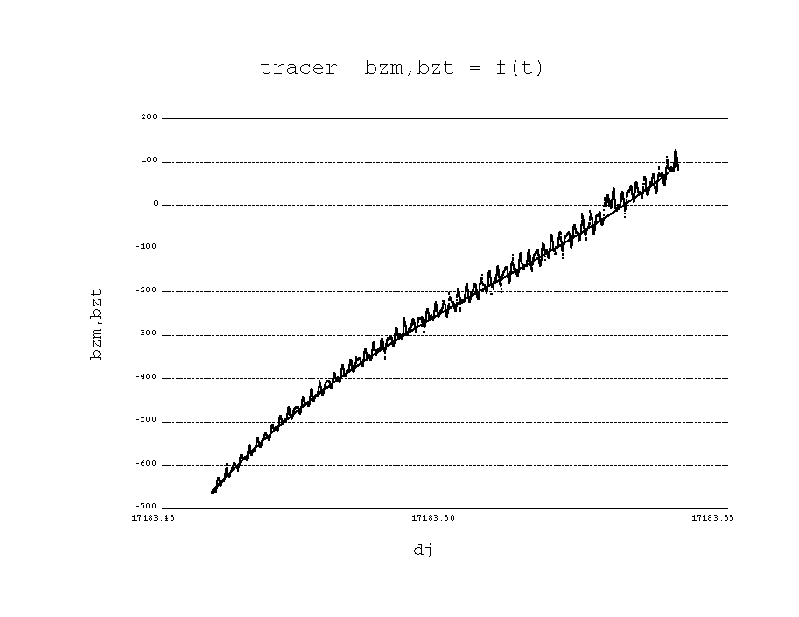
Fig.16

Another problem can be encountered when the determination of the attitude of the initial point is performed in a perturbed magnetic field region such as a FAC’s region. Figures 17, 18 and 19 show the subsequent consequence on the Euler-Poinsot integration process.

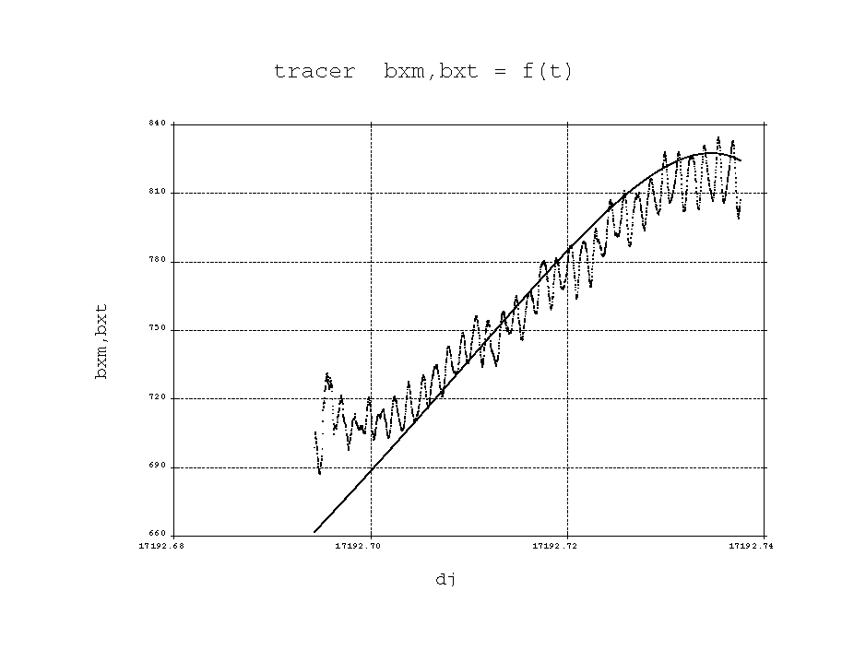
Fig. 17
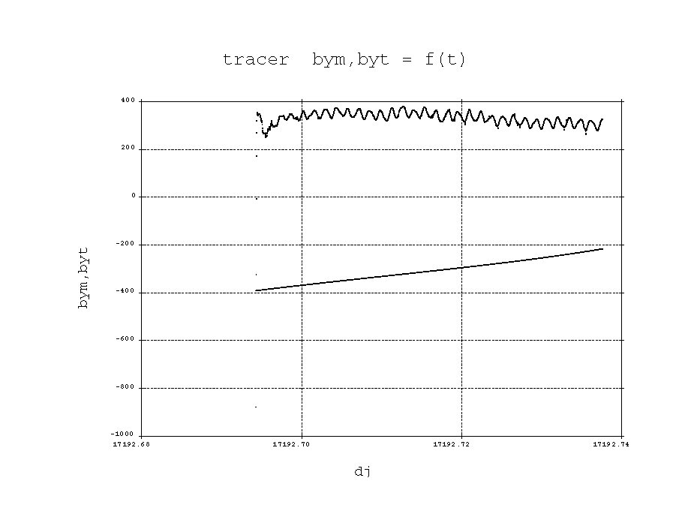
Fig.18
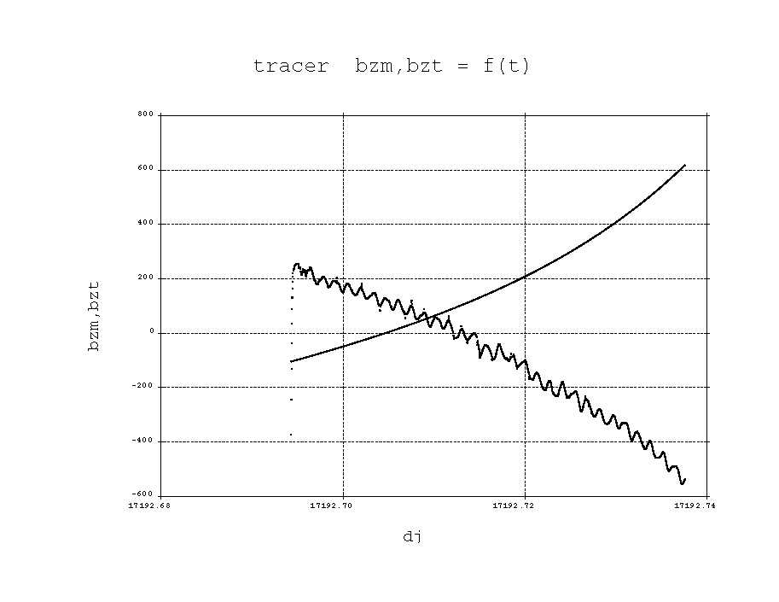
Fig.19

Figures 20,21 and 22 show a typical case of orbitography offset : the position of the spacecraft at some time t is different from the one by the orbitgraphy . The calculated reference field does not coincide with the measured magnetic field due to this orbit shift.
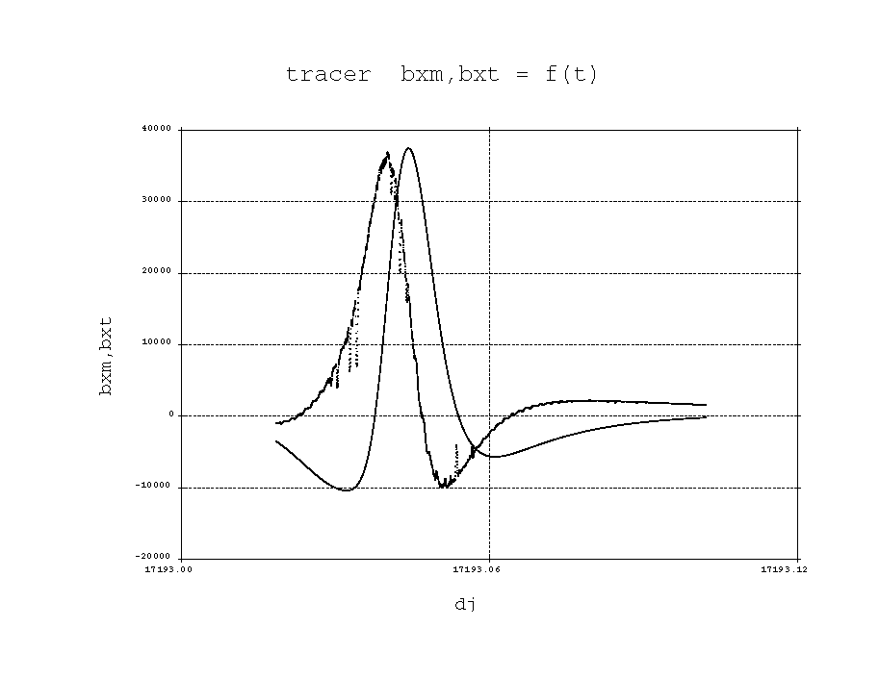
Fig.20
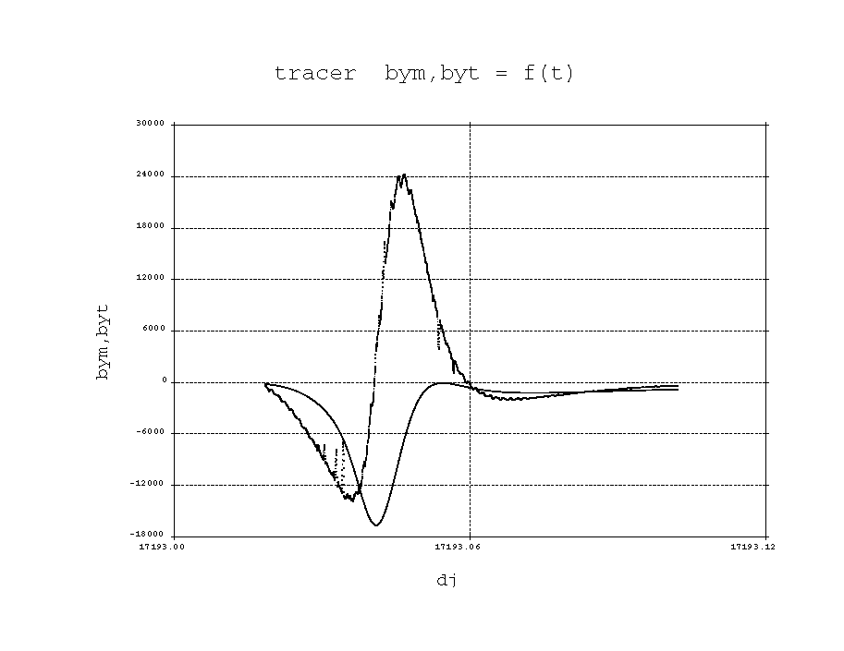

Fig.21
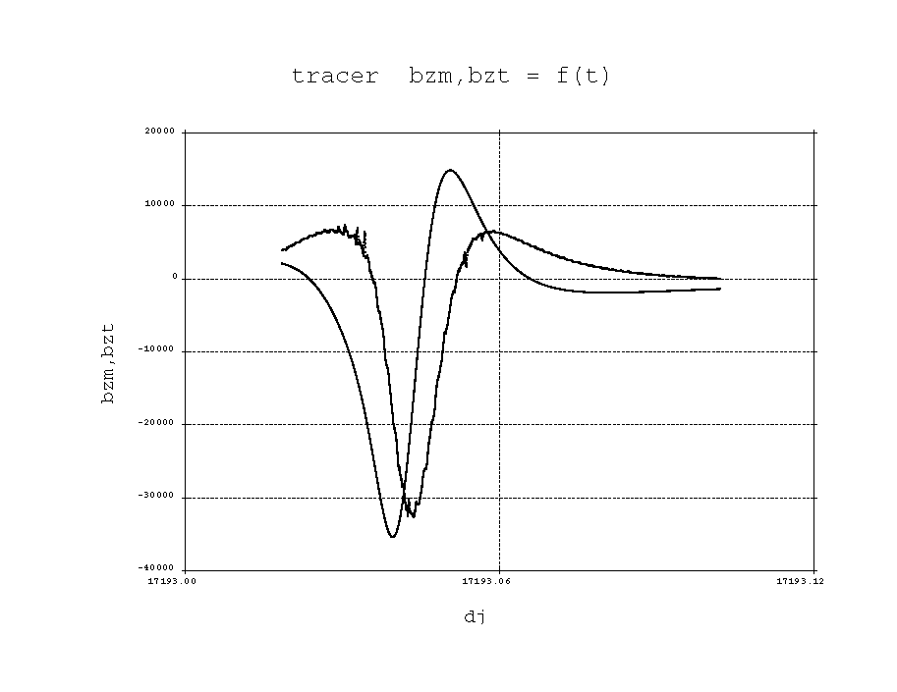
Fig.22

Calculation of the precise attitude :
With the knowledge of the star camera orientation in the spacecraft frame of reference is is thus possible to calculate the star camera boresight in the inertial frame. We set a magnitude limit, 5 in the case of the auroral camera, and define an enlarged field of view of the star camera and thus take into account the attitude uncertainty effects. From the catalogue of stars we can extract a subset of stars which belong to the auroral camera field of view. We then project these stars onto the star camera field of view. Part of the aurora camera field of view is hidden by the Earth and only stars outside the limb of the Earth will be available for the identification as shown in the figure below.
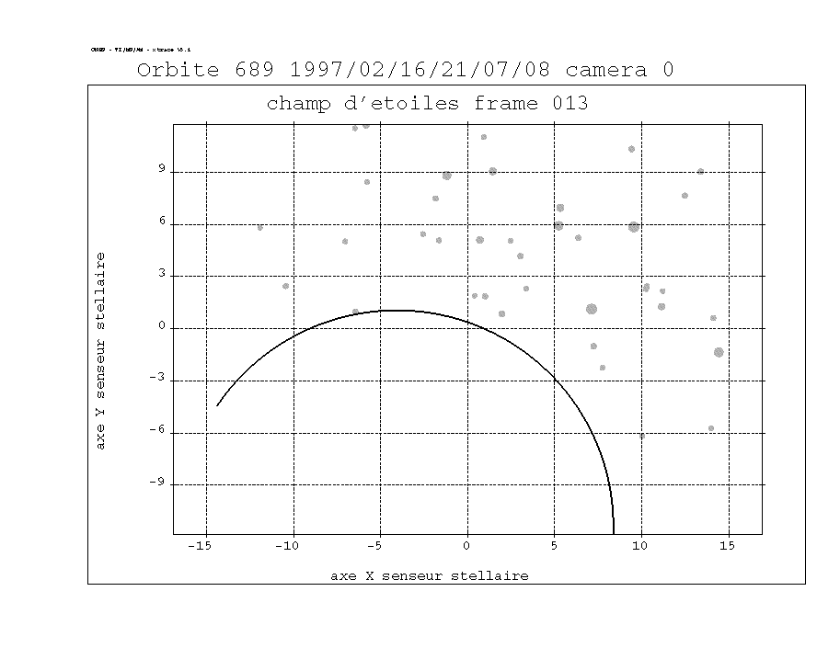

At this stage we have two subsets : the subset of catalogue stars and the subset of measured stars. The identification of the measured stars can take place using the orientation-angle algorithm described above. In this algorithm we have the possibility, depending on the number of the measured stars, to choose 2, 3 or 4 measured stars. After adjustment of the parameters, the identification will be successfull if only one duo, trio or quartet of catalogue stars is found. Now we have the positions of the identified stars both in the star camera frame of reference and in the inertial frame of reference. It is thus possible to use the TRIAD method or a least squares method to obtain the transformation matrix between the inertial frame of reference and the star camera frame of reference. Hence we can deduce from the attitude of the star camera the attitude of the spacecraft. The Auroral spacecraft has two cameras which deliver two star patterns at the same time. It is thus possible to estimate the accuracy of the attitude. The attitude of the Auroral spacecraft has been calculated for orbit 689 and the two on-board cameras. The results are presented in Table I. In the best cases a precision of 0.01 degree can be achieved.

TABLE I

Date | Hour | Camera | Number of stars in the field of view | Number of measured stars | Euler  rotation
97/2/11 | 2h 18mn 41s | 0 | 40 | 3 | 4.847
same | same | 1 | 29 | 3 | 5.161
97/2/11 | 2h 20mn 41s | 0 | 38 | 3 | 4.983
same | same | 1 | 27 | 3 | 4.875
97/2/11 | 2h 22mn 40s | 0 | 41 | 3 | 4.954
same | same | 1 | 27 | 2 | 5.089
97/2/11 | 2h 24mn 39 | 0 | 44 | 3 | 5.896
same | same | 1 | 29 | 2 | 5.878
97/2/11 | 2h 26mn 39 | 0 | 40 | 3 | 5.113
same | same | 1 | 26 | 2 | 5.222
97/2/11 | 2h 28mn 39 | 0 | 37 | 2 | 5.048
same | same | 1 | 22 | 2 | 5.074
97 /2/11 | 2h 30mn 38 | 0 | 40 | 3 | 5.839
same | same | 1 | 25 | 2 | 4.248

It is possible to evaluate the discrepancy between the approximate attitude obtained with the triad method plus the Euler-Poinsot extrapolation and the precise attitude obtained with the star cameras : One can calculate the generalized Euler rotation between the precise spacecraft attitude and the approximate attitude as mentionned by Markley (Ref.4). It is simply defined as :

$\text{cos}Φ = \frac{\left(\text{tr}\left(A\right)−1\right)}{2}$

where $\text{tr}\left(A\right)$ is the trace of the transformation matrix $A$ between the approximate spacecraft attitude frame and the precise spacecraft attitude frame.
From table I , one can notice that this angle $Φ$ is around 6 degrees.

Conclusion :
The auroral cameras on-board the Auroral spacecraft offer a unique possibility to test star identification algorithms. Presently only one algorithm has been tested and intensively used, the distance-orientation algorithm. Other algorithms, like the polygonal match and the pivot algorithm will be adapted to the Sun workstation. Frames containing up to 10 measured stars offer the possility to test the pivot algorithm also developed for the Gamma project. This algorithm did not work properly for Gamma because of the insufficient number of measured stars. Results obtained with the distance-orientation algorithm indicate a discrpancy of about 6 ° between the attitude calculated with the magnetic field and the Sun vectors and the attitude calculated with the stars for orbit 689. Early results for orbit 713 seems to corroborate this figure. Further work will continue with the star camera data base and the other algorithms. Consequences for the classical attitude will be drawn by a reevaluation of the magnetic measurements (biases,offsets). The attitude motion of the spacecraft will require more fundamental work on the possible influence of flexible booms or other energy exchange effects.

REFERENCES

Ref .1 : Gottlieb D.M. : Star Identification Techniques, in Wertz, p 259.

Ref.2 : Kosik J.Cl. : Star Pattern Identification Aboard an Inertially Stabilized Spacecraft, Jal. of Guidance, Control, and Dynamics, Vol.14, 2, p.230, 1991.

Ref. 3 :Lerner G. : Three-Axis Attitude Determination, in Wertz, p.420.

Ref.4 : Markley F.L. : Parametrization of the Attitude, in Wertz, p.410.

Ref.5 :Wertz J.R. : Spacecraft Attitude Determination and Control , D.Reidel Publishing Company, 1974, Dordrecht, Holland.

